Annotation

Introduction

What is Annotation?
Annotation is the act of adding notes or comments to a document, text, image, or other media in order to provide additional information or clarification. Annotations can be used for various purposes, such as research, feedback, revision, or sharing insights or ideas, and may include text or multimedia elements, such as hyperlinks, images, or audio recordings. Annotations can be handwritten or digital and can be done individually or collaboratively. They are often used in educational settings, where they can enhance students' reading comprehension, critical thinking skills, and engagement with the material.

Types of Annotation Services:

Data Annotation
- Image Annotation
- Image Classification
- Semantic Segmentation
- Instance Segmentation
- Object Detection
- Video Annotation
- Polyline Annotation
- Key point Annotation
- Landmark Annotation

Lider Annotation
- Text Annotation

- IMAGE ANNOTATION:
Image annotation can be understood as the process of labeling images to outline the target characteristics of your data on a human level. The result is then used to train a model and, depending on the quality of your data, achieve the desired level of accuracy in computer vision tasks.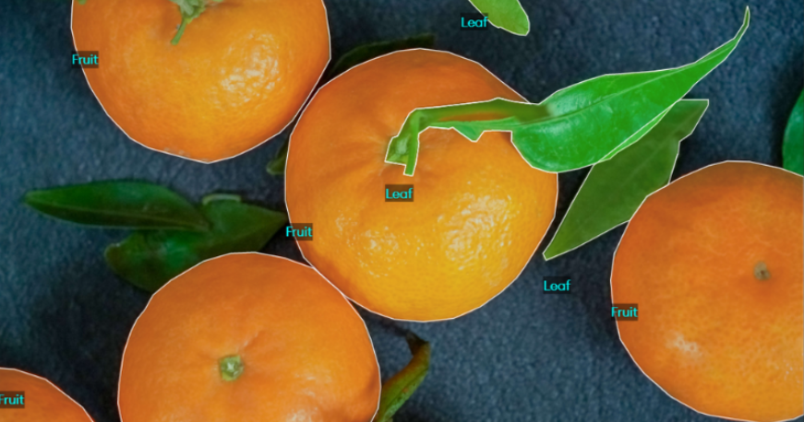

- IMAGE CLASSIFICATION:
Image classification is the task of assigning a label or class to an entire image. Images are expected to have only one class for each image.

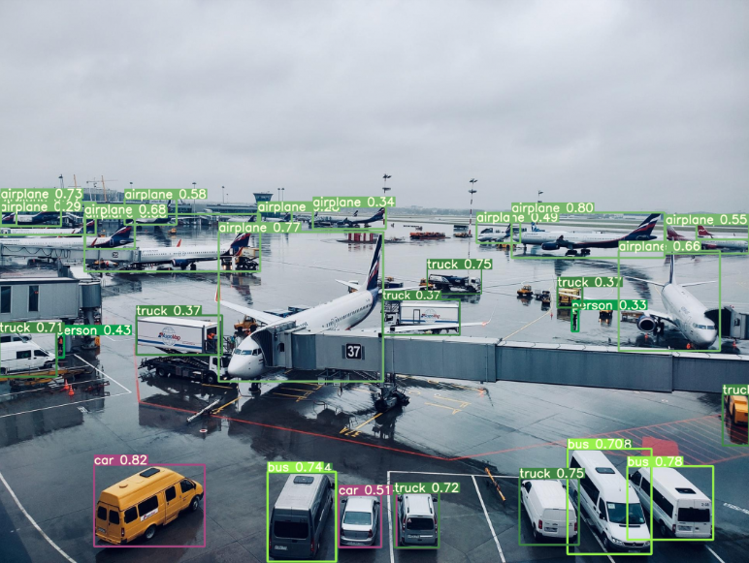

- SEMANTIC SEGMENTATION:
Depicts boundaries between similar objects. This method is used when great precision regarding the presence, location, and size or shape of the objects within an image is needed.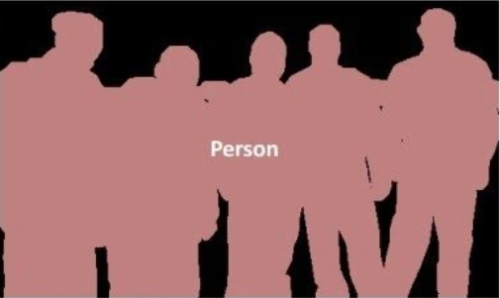

- INSTANCE SEGMENTATION:
identifies the presence, location, number, and size or shape of the objects within an image. Therefore, instance segmentation helps to label every single object’s presence within an image.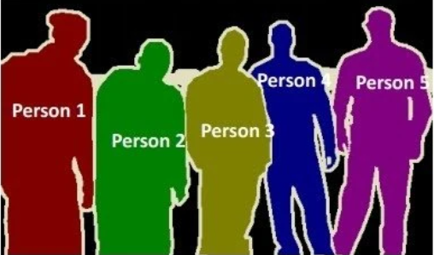

- Object Detection
Object recognition/detection is a further version of image classification. It is the correct description of the numbers and exact positions of entities in the image. While a label is assigned to the entire image in image classification, object recognition labels entities separately. For example, with image classification, the image is labeled as day or night. Object recognition individually tags various entities in an image, such as a bicycle, tree, or table.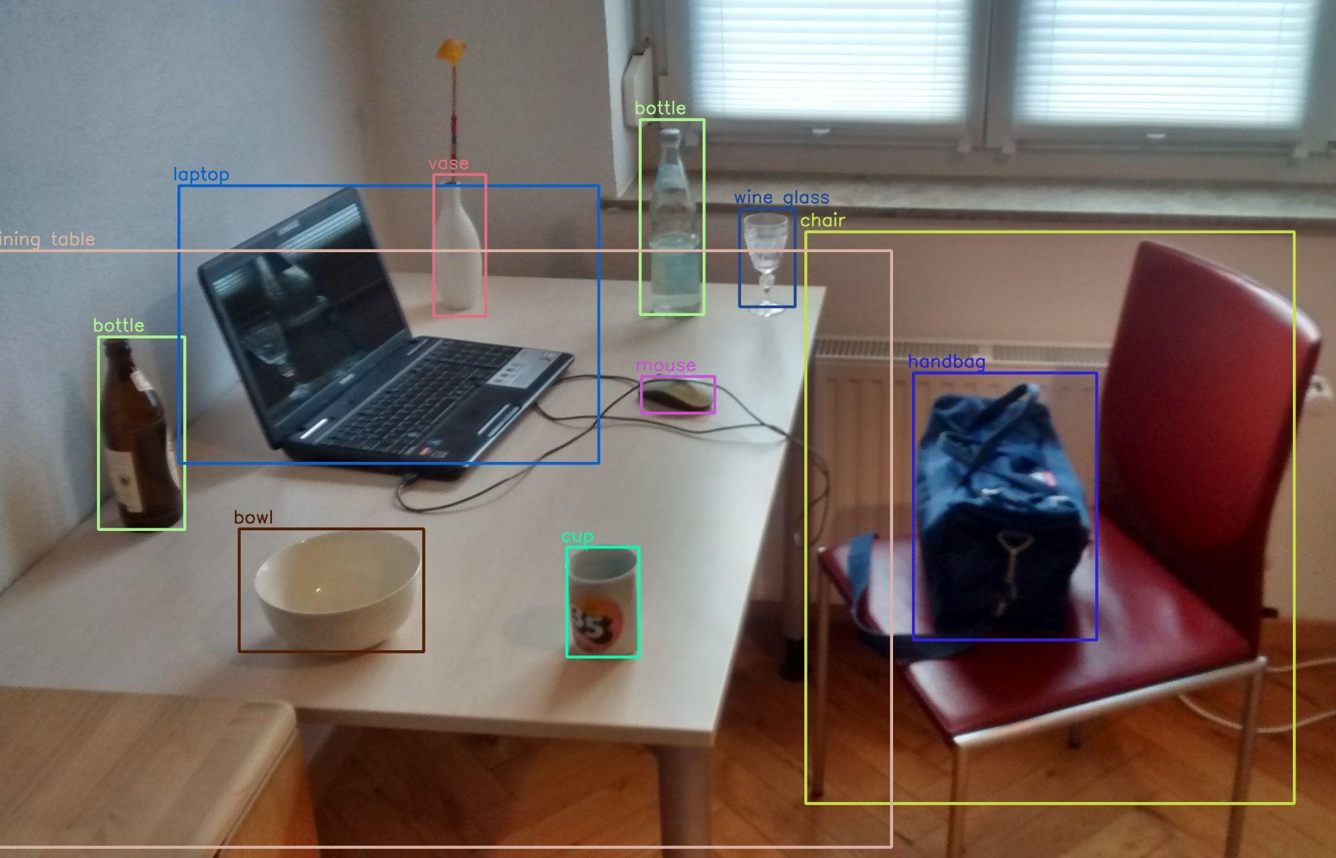

- VIDEO ANNOTATION:
Video annotation is the process of labeling or tagging video clips which are used for training computer vision models to detect or identify objects. Unlike image annotation, video annotation involves annotating objects frame-by-frame to make them recognizable for machine learning models.

- POLYLINE ANNOTATION:
This technique is used to define linear structures in images and video. It uses small lines, connected at vertices, to trace the shape of structures like roads, rail tracks, and pipelines. Annotators apply these lines to images using annotation platforms and labeling tools.
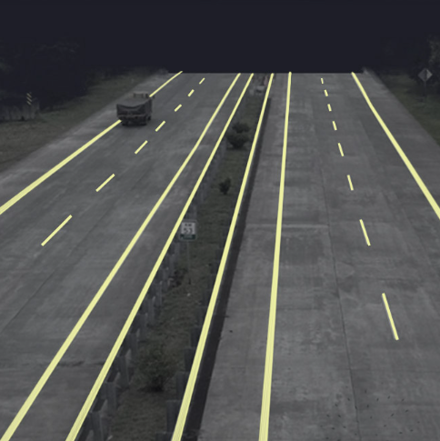

- KEYPOINT ANNOTATION:
Keypoint annotation consists of various particularly numbered points called key points which are connected by edges. They are a great way of tracking variations between objects which always have the same structure (e.g. human figures and facial features).
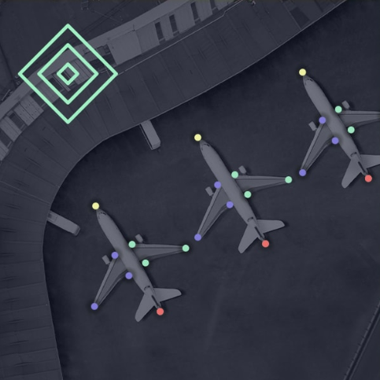

LANDMARK ANNOTATION:

Landmark annotation works by placing points across an image to label objects within that image. This kind of labeling ranges from single points to annotate small objects, and also multiple points to outline particular details. Images for landmark annotation can include maps, faces, bodies, and objects.

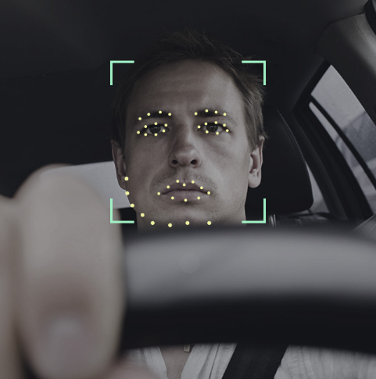

LIDER ANNOTATION:

Cuboid Annotation is the task of labeling objects in 2D images with cuboids. The 3D cuboids help to determine the depth of the targeted objects such as vehicles, humans, buildings, etc. Cuboid Annotation is used for building a 3D simulated world from 2D information captured by cameras.

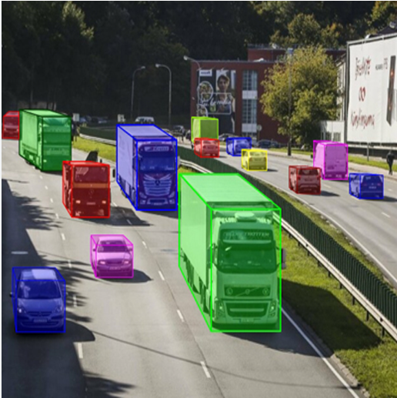

- TEXT ANNOTATION:
Text annotation is the practice and the result of adding a note or gloss to a text, which may include highlights or underlining, comments, footnotes, tags, and links.